NST21022 - Practical for Network Switching and Routing
Department of Information and Communication Technology
Faculty of Technology
Lab sheet :12
Reg. Number: SEU/IS/20/ICT/084
Academic Year :2020/2021
Practical No : 12

Title: Configure VLANs
Aim:
• Configure static and dynamic trucking protocol
• Configure inter-VLAN routing
Task:
• Configure static trucking protocol
• Configure dynamic trucking protocol
• Configure Router-on-a-Stick inter-VLAN routing

Activities

Exercise 01: Configure Static and Dynamic Trucking Protocol Use “NST21022 Lab sheet 12E1.pka” file

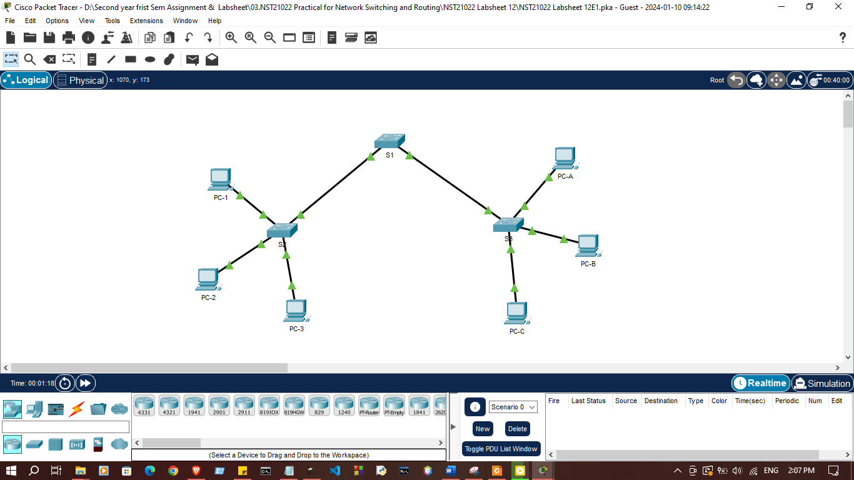
Addressing Table
Device | Interface | IP Address | Subnet Mask
PC-1 | NIC | 192.168.1.10 | 255.255.255.0
PC-2 | NIC | 192.168.2.10 | 255.255.255.0
PC-3 | NIC | 192.168.3.10 | 255.255.255.0
PC-A | NIC | 192.168.1.20 | 255.255.255.0
PC-B | NIC | 192.168.2.20 | 255.255.255.0
PC-C | NIC | 192.168.3.20 | 255.255.255.0

- Create additional VLANs on S1, S2 and S3 according to the table below.
VLAN Number | VLAN Name
10 | Red
20 | Green
30 | Blue
999 | Native

Switch>enable
Switch#configure terminal
Enter configuration commands, one per line. End with CNTL/Z.
Switch(config)#hostname S1
S1(config)#ip domain-name ccna.coma
S1(config)#vlan 10
S1(config-vlan)#name Red
S1(config-vlan)#vlan 20
S1(config-vlan)#name Green
S1(config-vlan)#vlan 30
S1(config-vlan)#name Blue
S1(config-vlan)#vlan 999
S1(config-vlan)#name Native
S1(config-vlan)#
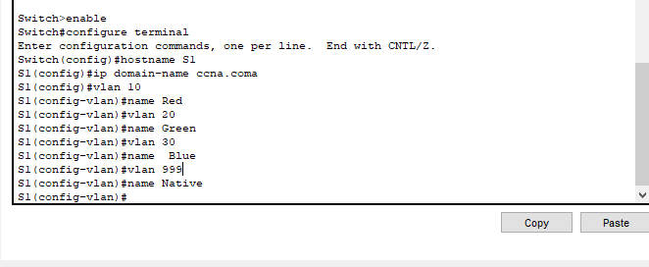
Switch>enable
Switch#configure terminal
Enter configuration commands, one per line. End with CNTL/Z.
Switch(config)#hostname S2
S2(config)#ip domain-name ccna.com
S2(config)#vlan 10
S2(config-vlan)#name Res
S2(config-vlan)#vlan 10
S2(config-vlan)#name Red
S2(config-vlan)#vlan 20
S2(config-vlan)#name Green
S2(config-vlan)#vlan 30
S2(config-vlan)#name Blue
S2(config-vlan)#vlan 999
S2(config-vlan)#name Native
S2(config-vlan)#

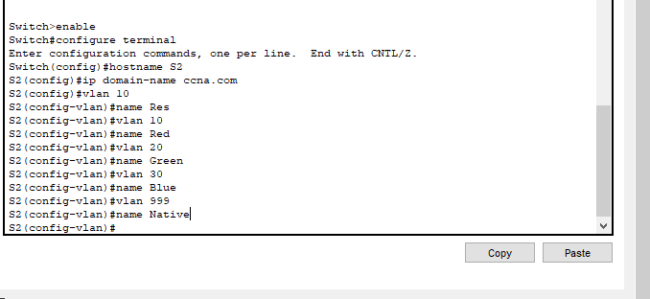
S3#
S3#enable
S3#configure terminal
Enter configuration commands, one per line. End with CNTL/Z.
S3(config)#hostname S3
S3(config)#ip domain-name ccna.com
S3(config)#vlan 10
S3(config-vlan)#name Res
S3(config-vlan)#vlan 10
S3(config-vlan)#name Red
S3(config-vlan)#vlan 20
S3(config-vlan)#name Green
S3(config-vlan)#vlan 30
S3(config-vlan)#name Blue
S3(config-vlan)#vlan 999
S3(config-vlan)#name Native
S3(config-vlan)#
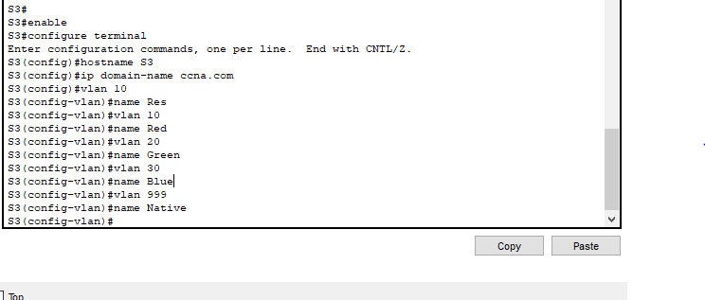

2. Assign Ports to VLANs
Ports | Assignments | Network
S2 F0/1 – 8  S3 F0/1 – 8 | VLAN 10 (Red) | 192.168.1.0/24
S2 F0/9 – 16  S3 F0/9 – 16 | VLAN 20 (Green) | 192.168.2.0/24
S2 F0/17 – 24  S3 F0/17 – 24 | VLAN 30 (Blue) | 192.168.3.0/24

S2(config)#interface fa0/1
S2(config-if)#int range fa0/1-8
S2(config-if)#int range fa0/1-8
S2(config-if-range)#switchport mode access
S2(config-if-range)#switchport access vlan 10
S2(config-if-range)#exit
S2(config)#interface fa0/11
S2(config-if)#int range fa0/9-16
S2(config-if-range)#switchport mode access
S2(config-if-range)#switchport mode access
S2(config-if-range)#switchport access vlan 20
S2(config-if-range)#exit
S2(config)#interface fa0/21
S2(config-if)#int range fa0/17-24
S2(config-if)#int range fa0/17-24
S2(config-if-range)#switchport mode access
S2(config-if-range)#switchport access vlan 30
S2(config-if-range)#exit
S2(config)#
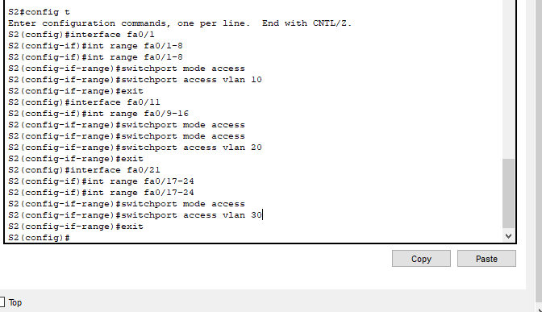
S3(config)#interface fa0/1
S3(config-if)#int range fa0/1-8
S3(config-if)#int range fa0/1-8
S3(config-if-range)#switchport mode access
S3(config-if-range)#switchport access vlan 10
S3(config-if-range)#exit
S3(config)#interface fa0/11
S3(config-if)#int range fa0/9-16
S3(config-if-range)#switchport mode access
S3(config-if-range)#switchport mode access
S3(config-if-range)#switchport access vlan 20
S3(config-if-range)#exit
S3(config)#interface fa0/21
S3(config-if)#int range fa0/17-24
S3(config-if)#int range fa0/17-24
S3(config-if-range)#switchport mode access
S3(config-if-range)#switchport access vlan 30
S3(config-if-range)#exit
S3(config)#
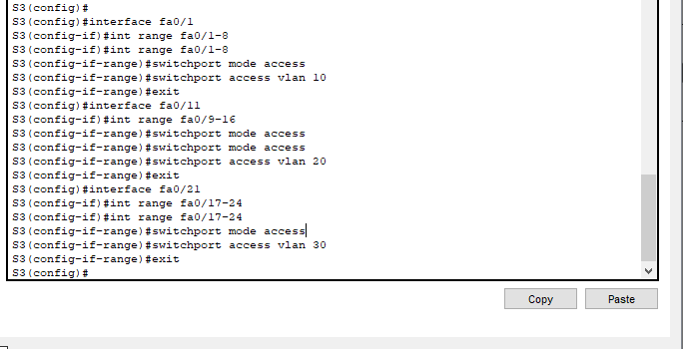

3. Dynamic trunking protocol (DTP) manages the trunk links between Cisco switches. Currently, all the switchports are in the default trunking mode, which is dynamic auto

a. On S1, configure the trunk link to dynamic desirable on the interface GigabitEthernet 0/1
S1(config)# interface g0/1
S1(config)# switchport mode dynamic desirable

S1(config)#interface g0/1
S1(config-if)#switchport mode dynamic desirable

S1(config-if)#
%LINEPROTO-5-UPDOWN: Line protocol on Interface GigabitEthernet0/1, changed state to up

%LINEPROTO-5-UPDOWN: Line protocol on Interface GigabitEthernet0/1, changed state to down

%LINEPROTO-5-UPDOWN: Line protocol on Interface GigabitEthernet0/1, changed state to up

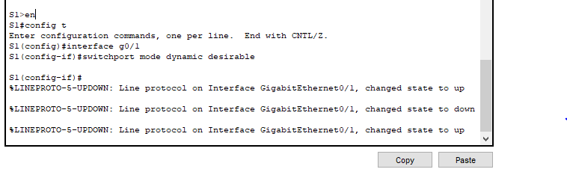

b. On S2, verify that the trunk has been negotiated by issue the show interface trunk command

S2#show interface trunk
Port Mode Encapsulation Status Native vlan
Gig0/1 auto n-802.1q trunking 1

Port Vlans allowed on trunk
Gig0/1 1-1005

Port Vlans allowed and active in management domain
Gig0/1 1,10,20,30,999

Port Vlans in spanning tree forwarding state and not pruned
Gig0/1 1,10,20,30,999
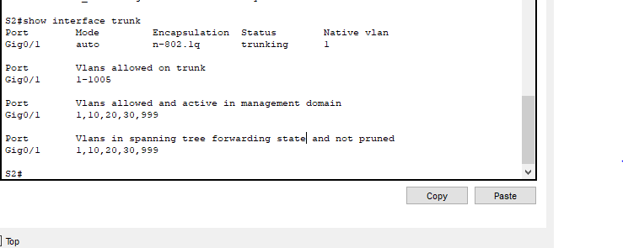

c. For the trunk link between S1 and S3, configure interface GigabitEthernet 0/2 as a static trunk link on S1. In addition, disable DTP negotiation on interface GigabitEthernet 0/2 on S1

S1(config)# interface g0/2
S1(config)# switchport mode trunk
S1(config)# switchport nonegotiate
configure interface GigabitEthernet 0/2 as a static trunk link on S3 also.

S1(config)#
S1(config)#
S1(config)#interface g0/2
S1(config-if)#switchport mode trunk
S1(config-if-range)#switchport trunk native vlan 999
S1(config-if)#switchport nonegotiate
S1(config-if)#exit
%LINEPROTO-5-UPDOWN: Line protocol on Interface GigabitEthernet0/2, changed state to down

%LINEPROTO-5-UPDOWN: Line protocol on Interface GigabitEthernet0/2, changed state to up

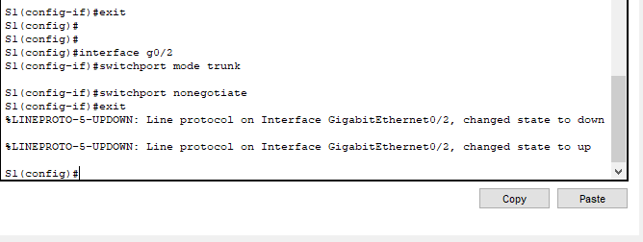
S1(config)#

S3(config)#interface g0/2
S3(config-if)#switchport mode trunk

S3(config-if)#switchport trunk native vlan 999
S3(config-if)#switchport nonegotiate
%LINEPROTO-5-UPDOWN: Line protocol on Interface GigabitEthernet0/2, changed state to down

%LINEPROTO-5-UPDOWN: Line protocol on Interface GigabitEthernet0/2, changed state to up

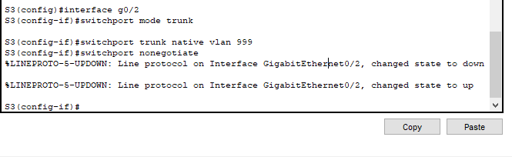
S3(config-if)#

d. Verify DTP status

S1# show dtp

S1#
S1#show dtp
Global DTP information
Sending DTP Hello packets every 30 seconds
Dynamic Trunk timeout is 300 seconds
1 interfaces using DTP
S1#
S1#
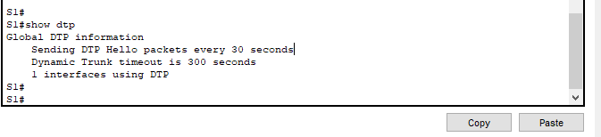

e. Verify trunking is enabled on all the switches
S1# show interface trunk

S1#show interface trunk
Port Mode Encapsulation Status Native vlan
Gig0/1 on 802.1q trunking 999
Gig0/2 on 802.1q trunking 999

Port Vlans allowed on trunk
Gig0/1 1-1005
Gig0/2 1-1005

Port Vlans allowed and active in management domain
Gig0/1 1,10,20,30,999
Gig0/2 1,10,20,30,999

Port Vlans in spanning tree forwarding state and not pruned
Gig0/1 1,10,20,30,999
Gig0/2 1,10,20,30,999

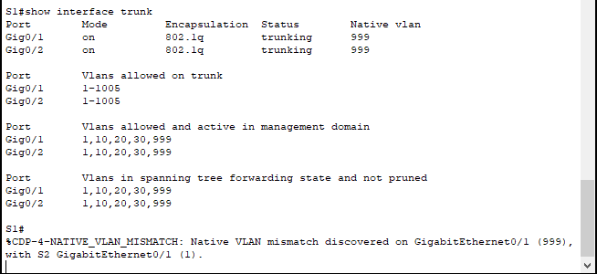
S1#

f. Configure VLAN 999 as the native VLAN for the trunk links on all switches.
S1(config)# interface g0/1
S1(config)# switchport trunk native vlan 999

S1(config)#interface range g0/1-2
S1(config-if-range)#switchport mode trunk
S1(config-if-range)#switchport trunk native vlan 999

S2(config-if)#interface g0/1
S2(config-if)#switchport mode trunk
S2(config-if)#switchport trunk native vlan 999

g. Notice that each PC can ping the other PC that shares the same subnet.
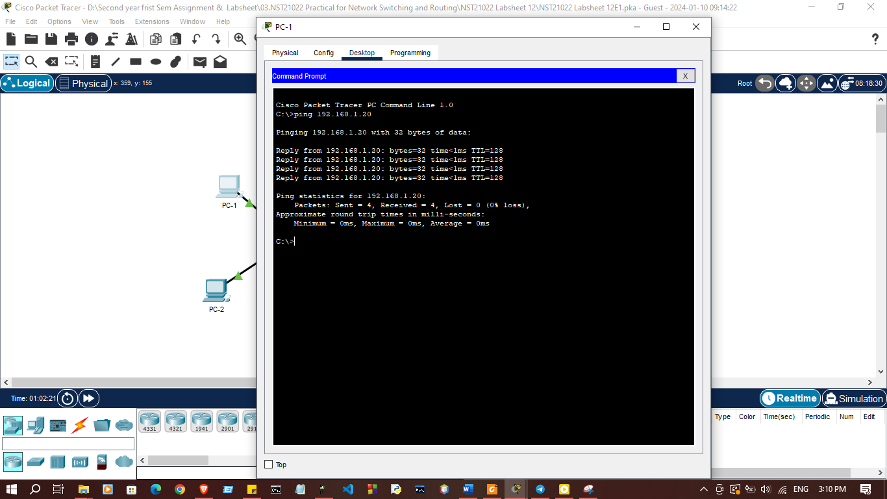
i. PC-1 can ping PC-A

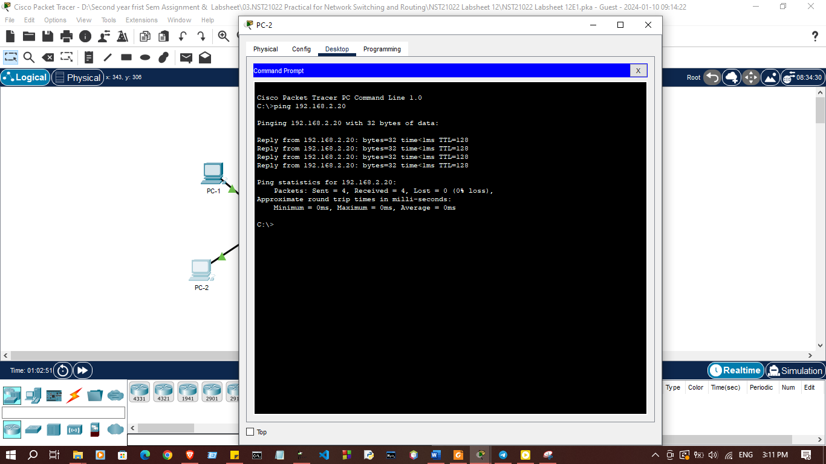
ii. PC-2 can ping PC-B

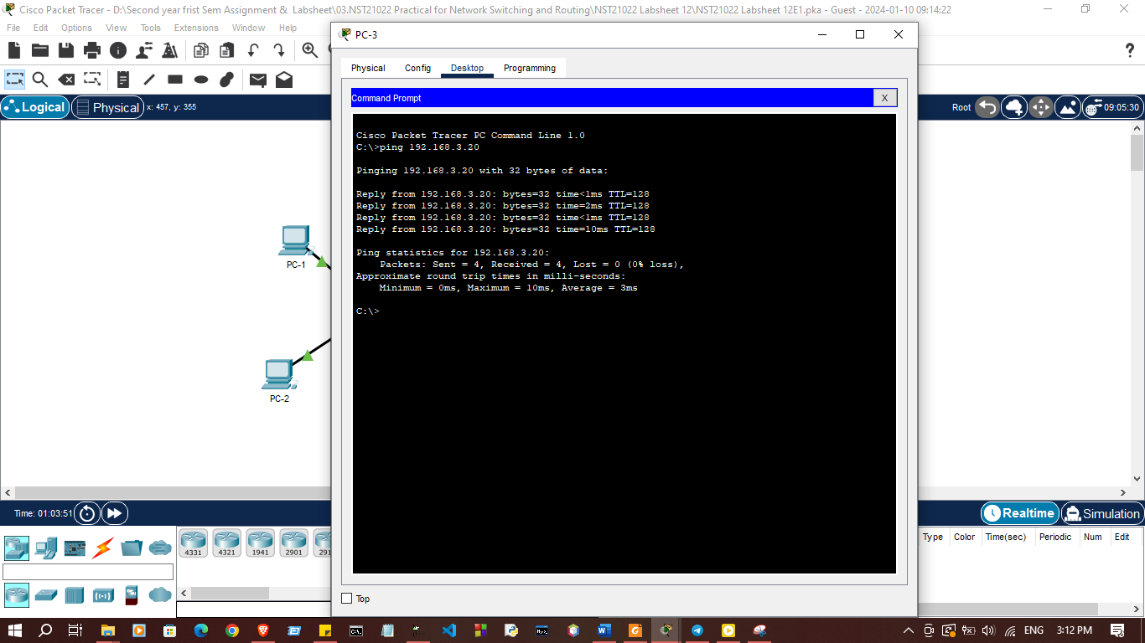
iii. PC-3 can ping PC-C

Exercise 02: Configure Router-on-a-Stick inter-VLAN routing Use “NST21022 Labsheet 12E2.pka” file

Addressing Table
Device | Interface | IP Address | Subnet Mask | Default Gateway
R1 | G0/0/0.10 | 192.168.1.1 | 255.255.255.0 | N/A
R1 | G0/0/0.20 | 192.168.2.1 | 255.255.255.0 | N/A
R1 | G0/0/0.30 | 192.168.3.1 | 255.255.255.0 | N/A
PC-A | NIC | 192.168.1.10 | 255.255.255.0 | 192.168.1.1
PC-1 | NIC | 192.168.1.11 | 255.255.255.0 | 192.168.1.1
PC-B | NIC | 192.168.2.10 | 255.255.255.0 | 192.168.2.1
PC-2 | NIC | 192.168.2.11 | 255.255.255.0 | 192.168.2.1
PC-C | NIC | 192.168.3.10 | 255.255.255.0 | 192.168.3.1
PC-3 | NIC | 192.168.3.11 | 255.255.255.0 | 192.168.3.1

- Create and name VLANs on S1

VLAN Number | VLAN Name
10 | Staffs
20 | Students
30 | Guests

S1>enable
S1#configure terminal
Enter configuration commands, one per line. End with CNTL/Z.
S1(config)#vlan 10
S1(config-vlan)#name Staffs
S1(config-vlan)#vlan 20
S1(config-vlan)#name Students
S1(config-vlan)#vlan 30
S1(config-vlan)#name Guests
S1(config-vlan)#
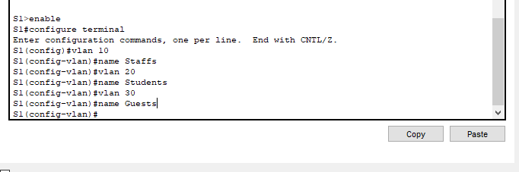
- Assign Ports to VLANs

Ports | Assignments | Network
S1 F0/1 – 2 | VLAN 10 (Staffs) | 192.168.1.0/24
S1 F0/11-12 | VLAN 20 (Students) | 192.168.2.0/24
S1 F0/21-22 | VLAN 30 (Guests) | 192.168.3.0/24

S1(config)#interface range fa0/1-2
S1(config-if-range)#switchport mode access
S1(config-if-range)#switchport access vlan 10
S1(config-if-range)#interface range fa0/11-12
S1(config-if-range)#switchport mode access
S1(config-if-range)#switchport access vlan 20
S1(config-if-range)#interface range fa0/21-22
S1(config-if-range)#switchport mode access
S1(config-if-range)#switchport access vlan 30
S1(config-if-range)#

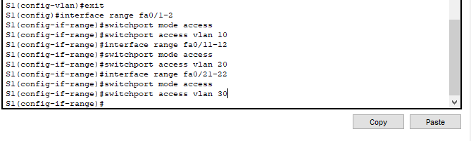
- Verify VLAN configuration
S1#show ip interface brief
Interface IP-Address OK? Method Status Protocol
FastEthernet0/1 unassigned YES manual up up
FastEthernet0/2 unassigned YES manual up up
FastEthernet0/3 unassigned YES manual down down
FastEthernet0/4 unassigned YES manual down down
FastEthernet0/5 unassigned YES manual down down
FastEthernet0/6 unassigned YES manual down down
FastEthernet0/7 unassigned YES manual down down
FastEthernet0/8 unassigned YES manual down down
FastEthernet0/9 unassigned YES manual down down
FastEthernet0/10 unassigned YES manual down down
FastEthernet0/11 unassigned YES manual up up
FastEthernet0/12 unassigned YES manual up up
FastEthernet0/13 unassigned YES manual down down
FastEthernet0/14 unassigned YES manual down down
FastEthernet0/15 unassigned YES manual down down
FastEthernet0/16 unassigned YES manual down down
FastEthernet0/17 unassigned YES manual down down
FastEthernet0/18 unassigned YES manual down down
FastEthernet0/19 unassigned YES manual down down
FastEthernet0/20 unassigned YES manual down down
FastEthernet0/21 unassigned YES manual up up
FastEthernet0/22 unassigned YES manual up up
FastEthernet0/23 unassigned YES manual down down
FastEthernet0/24 unassigned YES manual down down
GigabitEthernet0/1 unassigned YES manual down down
GigabitEthernet0/2 unassigned YES manual down down
Vlan1 unassigned YES manual administratively down down
S1#
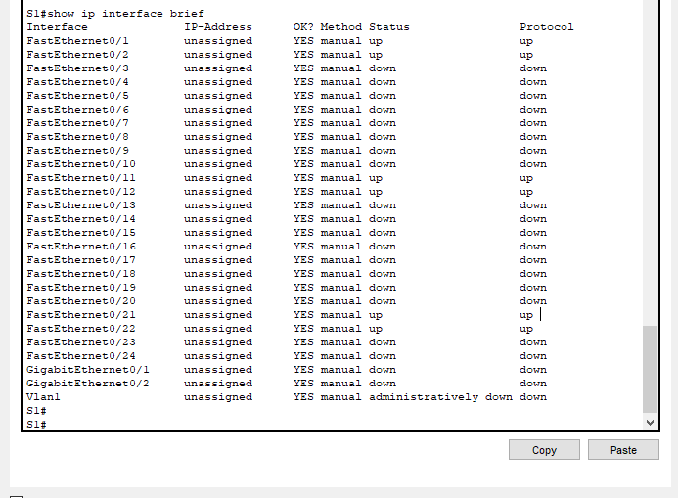
- 4. Configure sub interfaces on R1 using 802.1Q encapsulation a. Create the sub interfaces G0/0/0.10
- Set the encapsulation type 802.1Q, assign VLAN 10 and assign the correct IP address to the sub interface.

R1(config)# int g0/0/0.10
R1(config-subif)# encapsulation dot1Q 10
R1(config-subif)# ip address 192.168.1.1 255.255.255.0

R1>enable
R1#configure terminal
Enter configuration commands, one per line. End with CNTL/Z.
R1(config)#interface g0/0/0.10
R1(config-subif)#encapsulation dot1Q 10
R1(config-subif)#ip address 192.168.1.1 255.255.255.0
R1(config-subif)#no shutdown
R1(config-subif)#

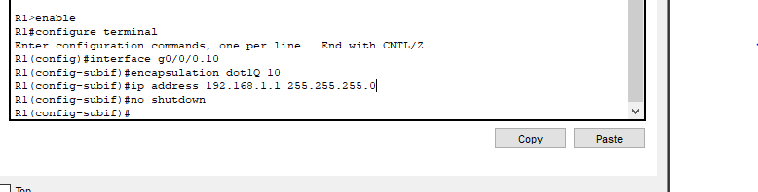

b. Repeat the steps for other 2 sub interfaces.

R1(config-subif)#interface g0/0/0.20
R1(config-subif)#encapsulation dot1Q 20
R1(config-subif)#ip address 192.168.2.1 255.255.255.0
R1(config-subif)#no shutdown
R1(config-subif)#
R1(config-subif)#interface g0/0/0.30
R1(config-subif)#encapsulation dot1Q 30
R1(config-subif)#ip address 192.168.3.1 255.255.255.0
R1(config-subif)#no shutdown
R1(config-subif)#
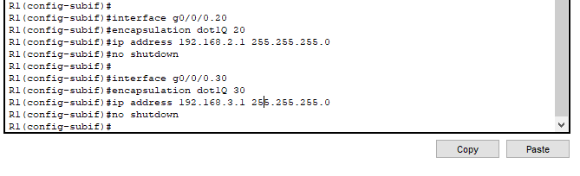

5. Verify configuration
a. Use show ip interface brief command to verify sub interface configuration.

R1#show ip interface brief
Interface IP-Address OK? Method Status Protocol
GigabitEthernet0/0/0 unassigned YES unset administratively down down
GigabitEthernet0/0/0.10192.168.1.1 YES manual administratively down down
GigabitEthernet0/0/0.20192.168.2.1 YES manual administratively down down
GigabitEthernet0/0/0.30192.168.3.1 YES manual administratively down down
GigabitEthernet0/0/1 unassigned YES unset administratively down down
GigabitEthernet0/0/2 unassigned YES unset administratively down down
Vlan1 unassigned YES unset administratively down down
R1#
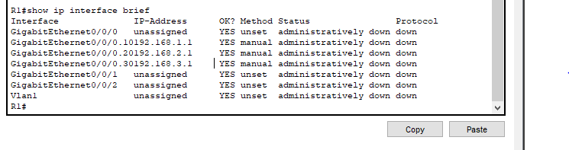

b. Enable G0/0/0 interface.

R1#configure terminal
Enter configuration commands, one per line. End with CNTL/Z.
R1(config)#
R1(config)#interface g0/0/0
R1(config-if)#no shutdown

R1(config-if)#

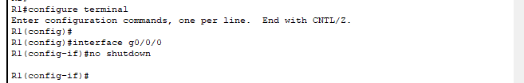

6. Try to ping between PCs on different networks.
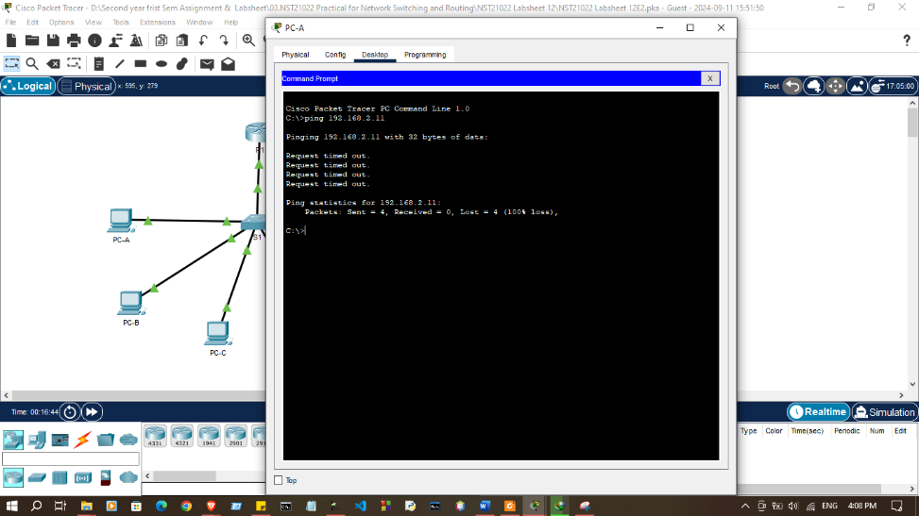
a. The pings should still fail.

b. Because the router was configured with multiple sub interfaces assigned to different VLANs, the switch port connecting to the router must be configured as a trunk. Enable trucking on interface G0/1.

S1(config)#interface g0/1
S1(config-if)#switchport mode trunk
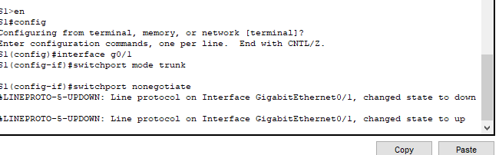

c. Verify the trunk configuration on S1

S1>en
S1#config
Configuring from terminal, memory, or network [terminal]?
Enter configuration commands, one per line. End with CNTL/Z.
S1(config)#interface g0/1
S1(config-if)#switchport mode trunk

7. Test connectivity.
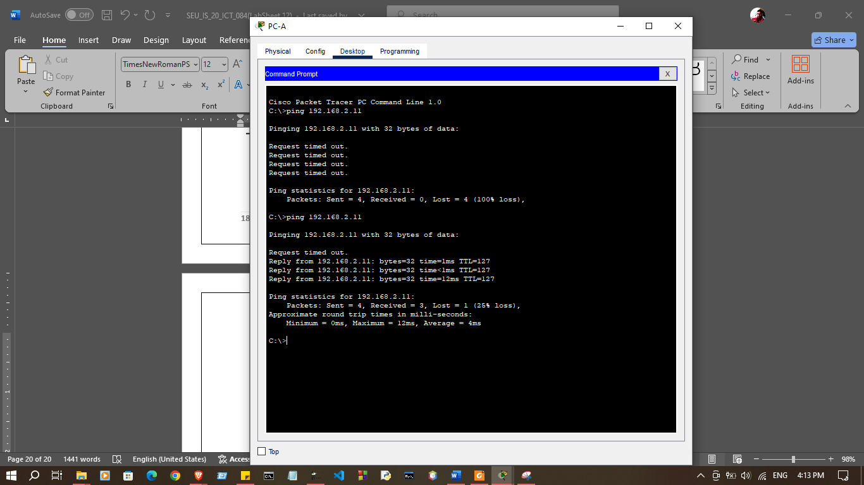

Discussion
- In this lab session, we focused on configuring both static and dynamic trucking protocols, as well as setting up inter-VLAN routing using the Router-on-a-Stick method. First, we established a static trunk by manually setting the trunk mode on the switch ports to allow VLAN traffic across different switches. Then, for dynamic trunking, we enabled Dynamic Trunking Protocol (DTP), which automatically negotiates the trunking state between switches. Finally, we implemented inter-VLAN routing through Router-on-a-Stick, where a single router interface was used to route traffic between multiple VLANs by creating subinterfaces for each VLAN. This configuration enables efficient communication between VLANs and facilitates network segmentation.

